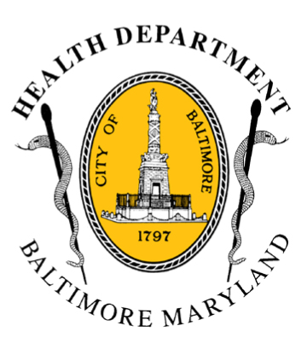
BCHD PRESS RELEASE
Baltimore City Health Department
1001 E. Fayette Street • Baltimore, Maryland 21202
Stephanie Rawlings-Blake, Mayor
Jacquelyn Duval-Harvey, PhD, Interim Commissioner of Health

FOR IMMEDIATE RELEASE

Media Contact: Michael Schwartzberg, PIO
O: (443) 984-2623 C: (443) 462-7939 E: michael.schwartzberg@baltimorecity.gov
Health Commissioner Declares Code Blue Alert
In Baltimore For Wednesday - Friday

BALTIMORE, MD (January 6, 2015) — With predicted low temperatures for Wednesday, Thursday and Friday this week in the teens, and wind chills in the single digits, the Interim Health Commissioner for Baltimore City is declaring a Code Blue for January 7, 8 & 9.

“We are expecting to have very cold temperatures in Baltimore later this week, with the potential of dangerously low wind chills”, said Dr. Jacquelyn Duval-Harvey, Interim Health Commissioner for Baltimore City. “We haven’t had cold weather like this in almost a year, so people need to be prepared and educated about the dangers.”

*Dr. Duval-Harvey will be available today (Tuesday, January 6^{th)}, at 11 a.m. at the Health Department, 1001 E. Fayette Street, for media interested in interviews.*

The greatest risk of illness and deaths due to cold weather is from December to February, with the risk peaking in January, typically the coldest winter month.
In the winter of 2013-14, there were 34 Code Blue days declared by the Health Commissioner and four hypothermia-related deaths in Baltimore City.

The Health Commissioner may declare a Code Blue alert based on the following criteria:

- When temperatures, including wind chill, are expected to be 13˚F or below. This threshold can be reached by having a temperature at or below 20˚F with 5 mph sustained winds or a temperature at or below 25˚F with 15 mph sustained winds.
- When other conditions (i.e. strong winds, forecasted precipitation for more than two hours, extended periods of cold, sudden cold after a warm period) are deemed by the Health Commissioner to be severe enough to present a substantial threat to the life or health of vulnerable Baltimore citizens.

Code Blue indicates an increased risk for cold injuries or even death for those exposed to low temperatures. Once a Code Blue declaration is made, public messaging activities are undertaken to encourage safety when outdoors and response partners work to ensure those in need find sheltering.

During a Code Blue, the Mayor’s Office of Human Services will continue to operate a 24-hour Housing & Resource Center for men and women at 620 Fallsway with 60 additional spaces available for residents seeking meals and sleeping quarters. Private homeless shelters will be encouraged to extend their hours and keep people indoors.
- more-
2-2-2
Baltimore Code Blue Stats For Past Three Winters
Winter Season | Code Blue Days Declared | Hypothermia-Related Deaths
2013-14 | 34 | 4
2012-13 | 10 | 5
2011-12 | 11 | 3

Cold Weather Tips for Staying Healthy:
- Wear multiple layers of loose-fitting clothing.
- Always wear a head covering, like a hat and/or scarf, when outdoors.
- Keep space heaters and candles away from flammable materials, such as curtains, furniture and loose clothing.
- Drink plenty of fluids and avoid alcoholic beverages.
- Check on those who are elderly and/or chronically ill.
- Provide appropriate shelter for domestic animals.
- Heart patients are advised against physical exertion in colder temperatures.
- Protect yourself against falls in icy or snowy conditions

Based on historical data from Baltimore and data from the Centers for Disease Control (CDC), the vulnerable populations in cold weather situations include:

- Street dwellers and the homeless
- Individuals abusing drugs (heroin/methadone), alcohol, or other substances
- Economically disadvantaged and without home heating
- Elderly persons and young children
- Individuals suffering from pre-existing heart conditions and diabetes
- Individuals with mental health problems

Extreme cold weather presents risks in addition to hypothermia as residents use prohibited alternative heat or power sources, such as a stoves and generators that may cause fire or carbon monoxide poisoning. Residents are encouraged to contact 311 if a neighbor is without heat or power so that city agencies can assist them. Energy assistance may be available to those who need it. For more information, individuals may contact the Office of Home Energy Programs at 410-396-5555.

Additional cold-weather resources for the public including a listing of city and private shelters, is available on the Health Department’s website (health.baltimorecity.gov). For other cold-related inquiries and service requests, or to find a nearby homeless shelter, residents can call 311 (410-396-3100 after hours).

###

